<http://ejournal.iaingorontalo.ac.id/index.php/JETLI>  *ISSN 2963-9565*

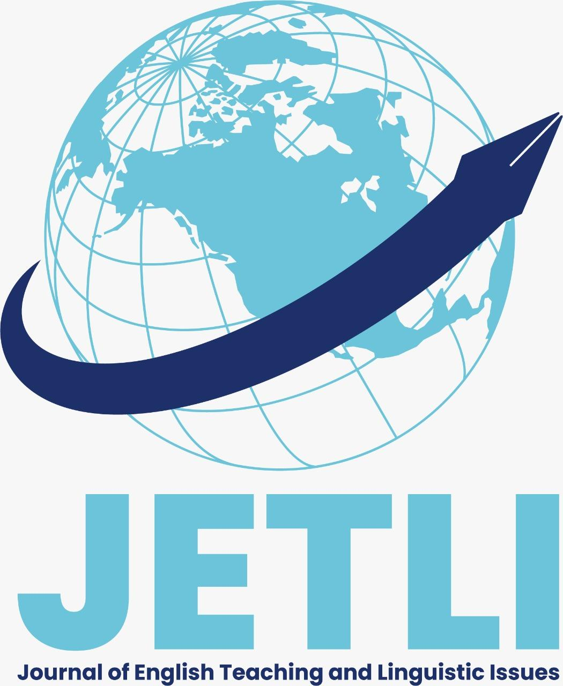



**CHALLANGES IN TEACHING MULTILINGUAL CLASSROOM**

**Zulfa Diana Romadhona1, Septika Ariyanti2 , Defy Gustianing3**

1Department of English Language Education, Aisyah Pringsewu University, Lampung, Indonesia

2Department of English Language Education, Aisyah Pringsewu University, Lampung, Indonesia

🖂 [zulfadiana288@gmail.com](mailto:zulfadiana288@gmail.com) [septika.ariyanti@gmail.com](mailto:septika.ariyanti@gmail.com) [defygustianing@gmail.com](mailto:defygustianing@gmail.com)

|  |
| --- |
| **Abstract**  The increasing presence of multilingual learners in diverse educational contexts has brought new challenges for language teaching worldwide. This literature review aims to synthesize key findings from these three perspectives to clarify recurring challenges, identify pedagogical gaps, and justify the need for innovative approaches to support multilingual education. The review employs a qualitative thematic synthesis of the selected articles, organizing the analysis around common themes such as monolingual teaching ethos, translanguaging implementation, teacher identity, and institutional limitations. The findings show consistent evidence that language teachers often struggle to balance political multilingual policies with classroom realities shaped by monolingual pedagogical traditions. While translanguaging is promoted as a potential bridge between students’ diverse linguistic repertoires and school expectations, its effective practice remains hindered by unclear goals, teacher discomfort, and insufficient institutional support. Moreover, the context of Pakistan illustrates how limited classroom time, lack of exposure, and inadequate training further complicate multilingual teaching practices at the secondary level. Overall, this review underscores the urgent need for systemic teacher training, the development of flexible multilingual pedagogies such as translanguaging, and supportive institutional frameworks to align policy goals with practical realities in multilingual education. |

**Article information:**

Received : juni 2025

Revised : Juni 2025

Accepted : Juli 2025

**Keywords**: Multilingual classroom, Teacher identity,Llanguage policy

**INTRODUCTION**

Teaching English in multilingual classrooms has become an increasingly complex issue in today’s education, both globally and locally. In urban public schools, for example, diverse student linguistic backgrounds present significant challenges for language teachers. This review explores key issues in multilingual language teaching, focusing on how translanguaging practices, teacher identity, and systemic limitations affect second language learning. Michael Kelly (2015) highlights the conflict between monolingual teaching traditions and multilingual realities in higher education, urging a shift toward transnational teacher identities and greater institutional collaboration. Mahera Shoaib and Nimrah Ayaz (2021) examine challenges in Pakistani public schools, such as limited teaching time, inadequate training, and low English exposure. Meanwhile, Ticheloven et al. (2021) address the practical difficulties of implementing translanguaging pedagogy, including unclear goals and assessment challenges. By synthesizing these perspectives, this review aims to identify core barriers in multilingual classrooms and explore alternative strategies—particularly translanguaging and teacher development—for more effective and inclusive language instruction.

**METHODS**

This literature review used a qualitative thematic synthesis method to analyze and compare findings from three selected studies: Kelly (2015), Shoaib & Ayaz (2021), and Ticheloven et al. (2021). The main focus was to identify structural, pedagogical, and policy-related challenges faced by teachers in multilingual classrooms. The studies were read carefully to extract objectives, contexts, and findings. Coding and thematic grouping were conducted manually, organizing similar ideas under major themes: structural and systemic challenges, pedagogical strategies, translanguaging, and teacher identity. This approach provides a holistic understanding of the recurring barriers and opportunities for improvement.

**RESULTS AND DISCUSSION**

**Results**

Structural and Systemic Challenges: Kelly (2015) describes the deep-rooted monolingual ethos in European higher education, rigid curricula, and native-speaker standards that hinder multilingual practices. Shoaib & Ayaz (2021) identify time constraints, limited exposure to English, and lack of teacher training in Pakistani schools. Ticheloven et al. (2021) highlight institutional policies that limit translanguaging implementation.

Pedagogical Strategies: Translanguaging and code-switching appear as adaptive methods but are often informal and unsupported by systematic training. Ticheloven et al. (2021) discuss seven dilemmas teachers face, such as unclear goals and classroom management issues.

Translanguaging and Linguistic Identity: Kelly (2015) and Ticheloven et al. (2021) stress how translanguaging supports student identity and inclusion, but lack of structured frameworks can lead to confusion. Shoaib & Ayaz (2021) emphasize the political and cultural sensitivities involved in integrating native languages.

Overall, the studies reveal that while translanguaging offers a promising approach, its effective use demands teacher development, institutional support, and context-sensitive policies.

**CONCLUSIONS**

This literature review concludes that teaching English in multilingual classrooms is complex due to persistent gaps between policy and practice. Structural monolingual traditions, insufficient training, and unclear pedagogical frameworks limit the adoption of multilingual strategies like translanguaging. Future research should investigate teacher training models, teacher identity development, policy-practice alignment, and multilingual assessment methods to bridge these gaps and enhance inclusive language education.

**REFERENCES**

**Book:**

Garcia, O., & Wei, L. (2014). Translanguaging: Language, bilingualism and education. Palgrave Macmillan. Cummins, J. (2000). Language, power and pedagogy: Bilingual children in the crossfire. Multilingual Matters.

**Journal article:**

Kelly, M. (2015). Challenges to multilingual language teaching: Towards a transnational approach. European Journal of Language Policy, 7(1). DOI:10.3828/ejlp.2015.5

Shoaib, M., & Ayaz, N. (2021). A study on the challenges faced by teachers in teaching English in multilingual classrooms at secondary level in public schools of Liaquatabad Town Karachi. Pakistan Journal of Educational Research, 4(4).

Ticheloven, A., Blom, E., Leseman, P., & McMonagle, S. (2021). Translanguaging challenges in multilingual classrooms: Scholar, teacher and student perspectives. International Journal of Multilingualism, 18(3), 491–514. [DOI:10.1080/14790718.2019.1686002](https://doi.org/10.1080/14790718.2019.1686002)

Hornberger, N. H., & Link, H. (2012). Translanguaging in today's classrooms: A biliteracy lens. Theory Into Practice, 51(4), 239–247. Canagarajah, S. (2011). Codemeshing in academic writing: Identifying teachable strategies of translanguaging. Modern Language Journal, 95(3), 401–417.

Wei, L. (2018). Translanguaging as a practical theory of language. Applied Linguistics, 39(1), 9–30.